**DAILY ONLINE ACTIVITIES SUMMARY**

|  |  |  |  |  |  |  |  |
| --- | --- | --- | --- | --- | --- | --- | --- |
| **Date:** | **27/05/2020** | | | | **Name:** | **Samrin Banu** | |
| **Sem & Sec** | **8th B** | | | | **USN:** | **4AL16CS082** | |
| Online Test Summary | | | | | | | |
| **Subject** | | **IOT** | | | | | |
| **Max. Marks** | | **30** | | **Score** | | **28** | |
| Certification Course Summary | | | | | | | |
| **Course** | **Introduction to Hadoop** | | | | | | |
| **Certificate Provider** | | | **Great learning** | **Duration** | | | **20 mins** |
| Coding Challenges | | | | | | | |
| **Problem Statement:**  **1) Write a C program to print all permutations of a given string using pointers**. | | | | | | | |
| **Status: Solved** | | | | | | | |
| **Uploaded the report in Github** | | | | **YES** | | | |
| **If yes Repository name** | | | | **Samrinbanu** | | | |
| **Uploaded the report in slack** | | | | **YES** | | | |

**Online Test Details**:



**Certification Course Details:**

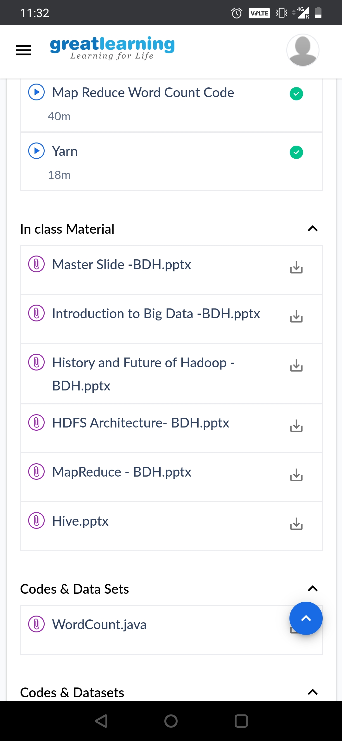

# Yaran:

# YARN is an Apache Hadoop technology and stands for Yet Another Resource Negotiator.YARN is a large-scale, distributed operating system for big data applications.The technology is designed for cluster management and is one of the key features in the second generation of Hadoop, the Apache Software Foundation’s open source distributed processing framework. YARN is a software rewrite that is capable of decoupling MapReduce’s resource management and scheduling capabilities from the data processing component.

# Benefits of YARN:

# The benefit of this is that it enables Hadoop to support more varied processing approaches and a broader array of applications, such as Hadoop clusters now being able to run interactive querying and streaming data applications along with MapReduce batch jobs.Combining a central resource management with node manager agents that monitor the processing operations of individual cluster nodes has helped to increase the appeal of YARN and Hadoop.

# The separation of HDFS from MapReduce with YARN has made Hadoop more suitable for operational applications that can’t wait for batch jobs to finish.

# CODE:

Program no:1

###Write a C program to print all permutations of a given string using pointers.###

#include <stdio.h>

#include <string.h>

void swap (char *x, char *y)

{

char temp;

temp = *x;

*x = *y;

*y = temp;

}

void permute(char *a, int i, int n)

{

int j;

if (i == n)

printf("%s\n", a);

else {

for (j = i; j <= n; j++)

{

swap((a + i), (a + j));

permute(a, i + 1, n);

swap((a + i), (a + j));

}

}

}

int main()

{

char a[20];

int n;

printf("Enter a string: ");

scanf("%s", a);

n = strlen(a);

printf("Permutaions:\n");

permute(a, 0, n - 1);

getchar() ;

return 0;

}